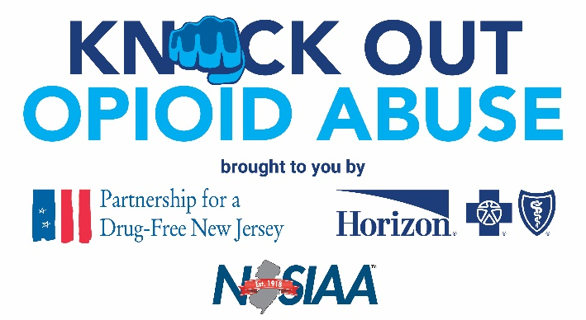
FOR IMMEDIATE RELEASE: May 25, 2023
Contact: Matt Birchenough, 201-916-1032, matt@drugfreenj.org
Former NFL Quarterback Ray Lucas Shares Personal Story of Opioid
Addiction and Recovery with Oakcrest High School Student-Athletes
MAYS LANDING, N.J. — Student-athletes at Oakcrest High School received an education on the risks of prescription opioids from a source with first-hand knowledge about the devastating impact of addiction.
New Jersey native and former NFL quarterback Ray Lucas spoke to hundreds of students gathered in the high school auditorium Tuesday morning about his rise to the top of his profession and how his addiction to opioids following his career almost brought his life crashing down.
The event was part of the Knock Out Opioid Abuse initiative, a program created by the Partnership for a Drug-Free (PDFNJ) and Horizon Blue Cross Blue Shield of New Jersey, in collaboration with the New Jersey State Interscholastic Athletic Association (NJSIAA). It was the final of 10 events to be held for high school students through the 2022-23 school year.
Lucas, a former star quarterback at Rutgers who enjoyed an eight-year career in the NFL, shared stories from his playing days and detailed how he developed an addiction to opioids and achieved recovery, while also urging students to stay educated and informed about the risks of prescription opioids.
“Injuries happen in high school sports so make sure to ask the questions about what you are being prescribed for pain and ask for help if you need it,” said Lucas. “Addiction does not discriminate. It can happen to anyone at any time.”

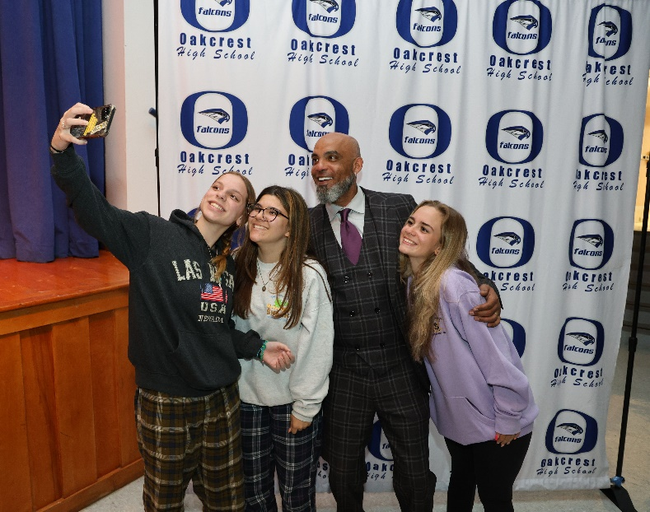
Former NFL quarterback Ray Lucas spoke to students at Oakcrest High School about his opioid addiction and recovery.
Football took its toll on Lucas, who sustained numerous injuries and underwent more dozens of surgeries during and after his playing career. He became dependent on prescription opioids, at times taking more than 1,400 pills a month. He has been open about his addiction and recovery in an effort to help others who have struggled with addiction and to prevent youth athletes from going down the path to addiction.
PDFNJ, Horizon and NJSIAA worked in collaboration with local organizations, Atlantic Prevention Resources and Join Together Atlantic County, to bring the event to Oakcrest High School.
“Atlantic Prevention Resources and Join Together Atlantic County are honored to be working with the PDFNJ on this important project,” said Atlantic Prevention Resources Executive Director Robert Zlotnick. “Former NFL QB Ray Lucas is very humble and honest about both his addiction and his recovery and we are grateful to have him here in Atlantic County to speak to students at Oakcrest High School. We also acknowledge his efforts throughout New Jersey to share this important message that can prevent other student athletes from the grave dangers of opioids and other substances."
Student-athletes have an elevated risk of opioid use as sports injuries send more than 2.6 million children to emergency rooms every year, according to the Centers for Disease Control and Prevention. The mission of this virtual conversation will be to educate student-athletes on the risks of prescription opioids, as well as the importance of taking care of themselves physically and mentally.
A Monitoring the Future survey also found that adolescent participants in high-injury sports had 50 percent higher odds of nonmedical use of prescription opioids than adolescents who did not participate in these types of sports. Students who are prescribed an opioid before graduating from high school increase their risk of future misuse by 33 percent.
In 2022, more than 2,800 people in New Jersey died of drug overdoses, a majority of which involved some form of opioid. In Atlantic County, there were 255 suspected overdose deaths and 1,031 naloxone administrations to reverse opioid overdoses last year.
# # #

Partnership for a Drug-Free New Jersey: Best known for its statewide substance use prevention advertising campaign, the Partnership for a Drug-Free New Jersey is a private not-for-profit coalition of professionals from the communications, corporate and government communities whose collective mission is to reduce demand for illicit drugs in New Jersey through media communication. To date, more than $200 million in broadcast time and print space has been donated to the Partnership’s New Jersey campaign, making it the largest public service advertising campaign in New Jersey’s history. Since its inception, the Partnership has garnered 217 advertising and public relations awards from national, regional and statewide media organizations.
About Horizon Blue Cross Blue Shield of New Jersey: Horizon Blue Cross Blue Shield of New Jersey, the state's oldest and largest health insurer is a tax-paying, not-for-profit health service corporation, providing a wide array of medical, dental, vision and prescription insurance products and services. Horizon BCBSNJ is leading the transformation of health care in New Jersey by working with doctors and hospitals to deliver innovative, patient-centered programs that reward the quality, not quantity, of care patients receive. Learn more at www.HorizonBlue.com. Horizon BCBSNJ is an independent licensee of the Blue Cross and Blue Shield Association serving more than 3.4 million members.

About The Horizon Foundation for New Jersey: The Horizon Foundation for New Jersey is committed to working alongside those who can help us improve our neighbors’ health, inform their health decisions and inspire them to lead healthier, more fulfilling lives. The Foundation’s funding pillars are Caring, Connecting and Creating. Horizon Blue Cross Blue Shield of New Jersey is the sole member of The Horizon Foundation for New Jersey, both of which are independent licensees of the Blue Cross and Blue Shield Association. For more information, please visit www.Horizonblue.com/Foundation
About the NJSIAA: Established in 1918, the New Jersey State Interscholastic Athletic Association (NJSIAA) is a voluntary, non-profit organization comprised of 436 accredited public and non-public high schools. A member of the National Federation of State High School Associations, the NJSIAA conducts tournaments and crowns champions in 33 sports. Championship competition for girls is sponsored in basketball, bowling, cross country, fencing, field hockey, golf, gymnastics, lacrosse, soccer, softball, swimming, tennis, outdoor track, winter track, volleyball, and wrestling. Boys’ championships are determined in baseball, basketball, bowling, cross country, fencing, football, golf, ice hockey, lacrosse, soccer, swimming, tennis, outdoor track, winter track, volleyball, and wrestling.

