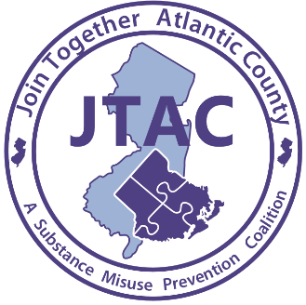

For Immediate Release
Contact: Laurie Smith
626 N Shore Rd
Absecon, New Jersey
Phone: (609) 272-0101 ext. 11
Email: Lsmith@atlprev.org
Date: 8/11/2020
Radio Town Hall Meeting: Marijuana In Our Community Today
Informative Conversation About Marijuana in Our Community
Absecon, NJ- 8/11/2020 Join Together Atlantic County and Atlantic Prevention Resources will be hosting a Radio Town Hall Meeting on the topic of marijuana in our community. The Radio Town Hall will take place Today, Tuesday, August 11th from 9:00AM until 10:00AM on WPG Talk Radio 1450 AM and 95.5 FM. Speakers will include Diane Litterer, New Jersey Prevention Network, and Will Jones, SAM Smart Approaches to Marijuana and will be moderated by Bob Zlotnick, Executive Director, Atlantic Prevention Resources and Harry Hurley, WPG Talk Radio.

Contrary to popular belief marijuana is addictive. This is especially true today with the level of THC rising to nearly three times the concentration compared to 25 years ago. The higher the THC amount, the stronger the effects on the brain—likely contributing to increased rates of marijuana-related emergency room visits. (SAMHSA).

To attend the Radio Town Hall Meeting click on the following link https://wpgtalkradio.com/wpg-talk-radio-104-1-is-moving-to-95-5-fm/ and then click “Listen Now” on the top right of the page. Listeners can call in with questions and/or comments by dialing (609)407-1450. Atlantic Prevention Resources is dedicated to preventing harm, caused by substance use and violence. Join Together Atlantic County, is a substance misuse prevention coalition whose goal is to prevent, reduce and or delay substance misuse among children. This coalition project is funded by a grant from ONDCP (Office of National Drug Control Policy). For additional information please email Lsmith@atlprev.org or call (609) 272-0101 ext. 11.

###

