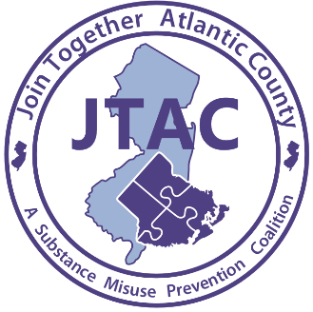

For Immediate Release
Contact: Laurie Smith
626 N Shore Rd
Absecon, New Jersey
Phone: (609) 272-0101 ext. 11
Email: Lsmith@atlprev.org
Date: 7/27/2020
15 Minute Child Break Webinars
Communicating with the children in our lives about drugs and alcohol during a pandemic
Absecon, NJ- 7/27/2020 - In collaboration with the Partnership for a Drug-Free New Jersey, Join Together Atlantic County and Atlantic Prevention Resources will be hosting two FREE 15 Minute Child Break webinars via Zoom. The webinars will take place on July 30th at 7:00PM and on August 5th at 2:00PM. They will be a one-hour interactive, multimedia webinar that will inform, encourage and empower you to effectively communicate with children about the danger of drugs and alcohol. Parents, grandparents, caregivers and those working with children are encouraged to participate.

During the COVID-19 pandemic it's more important than ever to communicate with the children in our lives, and to empower those who have children. The webinar will cover underage drinking, marijuana use, opioids and prescription drugs, vaping trends, tips for effectively talking to children and teens about healthy decisions, helping children manage stress, and utilizing teachable moments. “Parents who talk to their children about their activities an average of 15 minutes a day have children who are 67% less likely to try marijuana”.

This is a FREE webinar being offered twice to accommodate parents’ schedules. To register for the July 30th webinar please visit http://createsend.com/t/y-DADD561DFD9DC97C . To register for the August 5th webinar please visit http://createsend.com/t/y-A8F7F58BE2A5DE58 . Atlantic Prevention Resources is dedicated to preventing harm, caused by substance use and violence. Join Together Atlantic County, is a substance misuse prevention coalition whose goal is to prevent, reduce and or delay substance misuse among children. This coalition project is funded by a grant from ONDCP (Office of National Drug Control Policy). For additional information please email Lsmith@atlprev.org or call (609) 272-0101 ext. 11.

###

