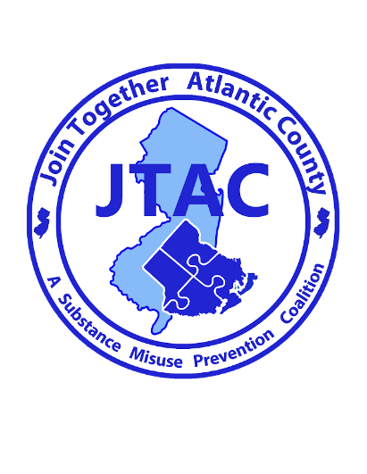

For Immediate Release

Contact: Anna Peterson
626 N Shore Rd
Absecon, New Jersey
Phone: (609) 272-0101 Ext. 271
Email: apeterson@atlprev.org
Date: 5/4/2023
Join Together Atlantic County to Sponsor “We Check for 21” Trainings
“JTAC is sponsoring workshops to address underage drinking throughout the county”
Absecon, NJ- 5/4/2023- Join Together Atlantic County, a county-wide substance misuse prevention coalition, will be sponsoring 3 free “We Check for 21” trainings on Wednesday, May 31, 2023. Restaurants, tavern and liquor store owners, managers, servers and bartenders will be reminded about the importance of checking identification of young adults in order to prove they are of legal age. The trainings will be held at 10:00 AM, 2:00 PM, and 5:00 PM in the Campus Center Theater at Stockton University in Galloway, NJ. Training sessions will last approximately 2 hours each.
The younger a person starts drinking, the more likely he or she is to have alcohol problems later in life. A person who starts drinking as a young teen is four times more likely to become a person with an alcohol use disorder than someone who does not drink until age 21. The brain is still forming in teenagers and teen drinking can cause irreversible damage.
The training will include a presentation from Joe Vasil of Vasil ID Training LLC. Joe Vasil will give a demonstration regarding fake licenses and other identification cards. Each establishment attending this event will receive a free I.D. Checking Guide, handheld black lights, and other “We Check for 21” materials. This training is being offered for free, but registration is required. Please contact Join Together Atlantic County to register at (609) 272-0101 Ext 271 or email JTACNJ@atlprev.org.
Participation in this event will support Join Together Atlantic County in their mission: “to prevent, reduce and/or delay substance use among youth of Atlantic County in a long term and sustainable manner.” Join Together Atlantic County is located at 626 N. Shore Road in Absecon, NJ.

###

