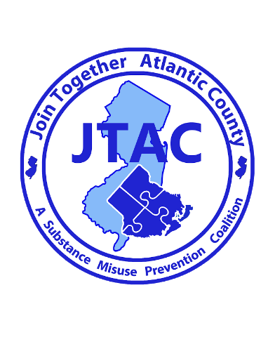

For Immediate Release

Contact: Brian J. Wilson
626 N Shore Rd
Absecon, New Jersey
Phone: (609) 272-0101 ext. 22
Email: Bwilson@atlprev.org,
Date: 9/22/2020
Bunting Family Pharmacy Acquires Permanent Prescription Drop Box

Local Pharmacy Helps Combat Prescription Drug Misuse by Offering Safe Drug Disposal
Northfield, NJ- 9/22/2020 Join Together Atlantic County (JTAC), a substance misuse prevention coalition has partnered with Bunting Family Pharmacy helping them secure a permanent prescription drop box for the public to dispose of unused, unwanted, and expired medications. The box is located inside Bunting Family Pharmacy located at 1337-a, New Rd, Northfield, NJ, 08225. It will be available to the public during normal business hours, which are 9:00AM until 7:00PM Monday through Friday, and from 9:00AM until 4:00PM on Saturday. You may contact Bunting Family Pharmacy at (609) 484-0026 or visit their website at https://buntingfamilypharmacy.com for additional information.

Bunting Family Pharmacy Owner, and Pharmacist in Charge Josiah Bunting along with Join together Atlantic Counties, Brian J. Wilson have worked diligently to provide this much needed service to the local community. Since 2008, Bunting Family Pharmacy has been a staple in the Northfield community and has always taken opportunities to give back to the community. They are extremely proud to help those looking for a safe way to dispose of unused or unwanted medications. Wilson stated that properly securing and disposing of your medications are important steps in helping to prevent the theft and diversion of powerful opioid medications.

Permanent drop boxes and the awareness campaigns surrounding them are an important part of reducing the misuse of prescription medication. 2 in 5 teenagers believe prescription drugs are “much safer” than illegal drugs. Every day in the U.S. 2,500 youths take a prescription pain reliever for the purpose of getting high for the first time. Cleaning out medicine cabinets will reduce the number of prescriptions available for abuse. Wilson commends Bunting Family Pharmacy for taking the initiative to help protect our environment and keep our communities safe by offering the public a safe way to dispose of their medications.

The prescription drop box was purchased by JTAC with funds through a DFC (Drug Free Communities) grant from the ONDCP (Office of National Drug Control Policy) and SAMHSA (Substance Abuse and Mental Health Services Administration). For more information about JTAC please visit www.jtacnj.org or call 609-272-0101 ext. 22.

JTAC challenges you to take the Five-Step American Medicine Chest Challenge:
• Take inventory of your prescription and over-the-counter medicine.
• Secure your medicine chest.
• Properly dispose of your unused, unwanted, and expired medicine.
• Take your medicine(s) exactly as prescribed.
• Talk to your children about the dangers of prescription drug abuse.

